Bio for Victor Dawson
Some of the words used to describe Victor are “Son of the Living God, Saint Saved by Grace, Ambassador for Christ, Husband, Father, Grandfather, Servant Leader, Entrepreneur, Global Business Owner, Author, Communicator, Triathlete, World Traveler, and Dog Lover.”
Victor is passionate about Evangelism and Discipleship by Living Out the Great Commission and has been involved in CBMC (Christian Business Men’s Connection) as a volunteer leader for 27 years. He has served as a member of the Board of Directors of CBMC USA for 7 years and CBMC International for 4 years. For the last 3 years he has been on the CBMC USA national staff responsible for New City Development.
He loves South Africa and has made 3 trips there in the last 8 years.
Victor has been married to his wife, Nan, for 47 years and they live in Colorado Springs, Colorado. They have two married children, a grandson (9), and a granddaughter (6).”
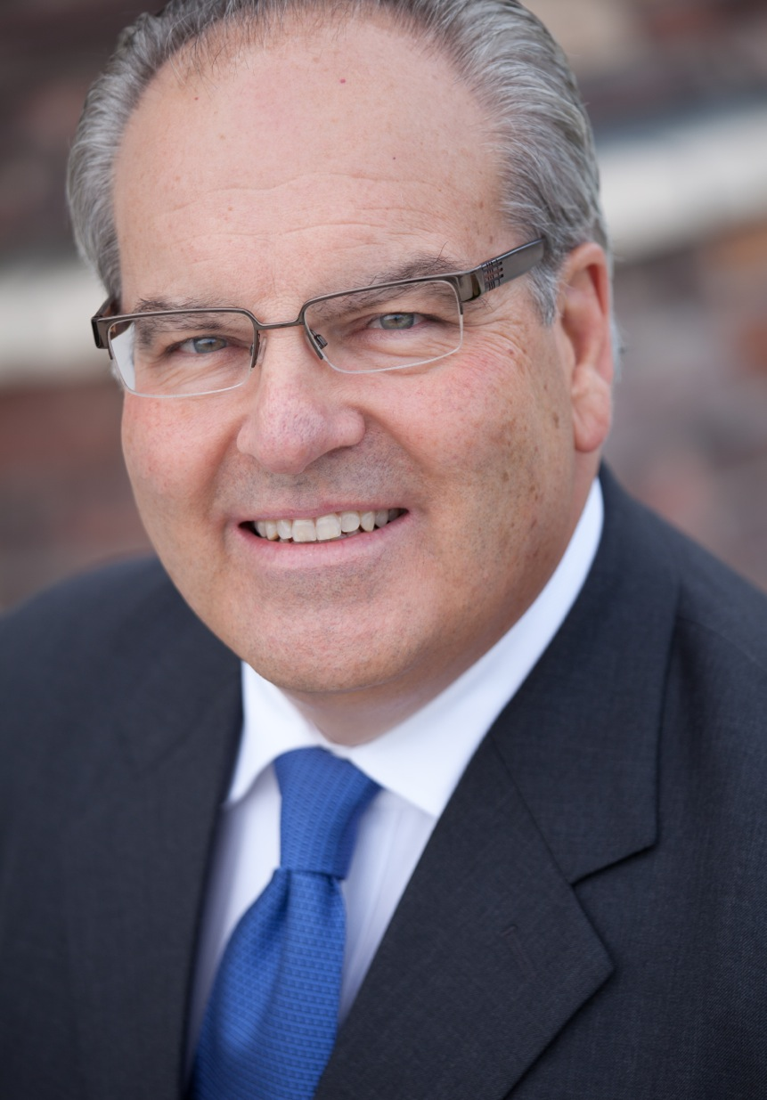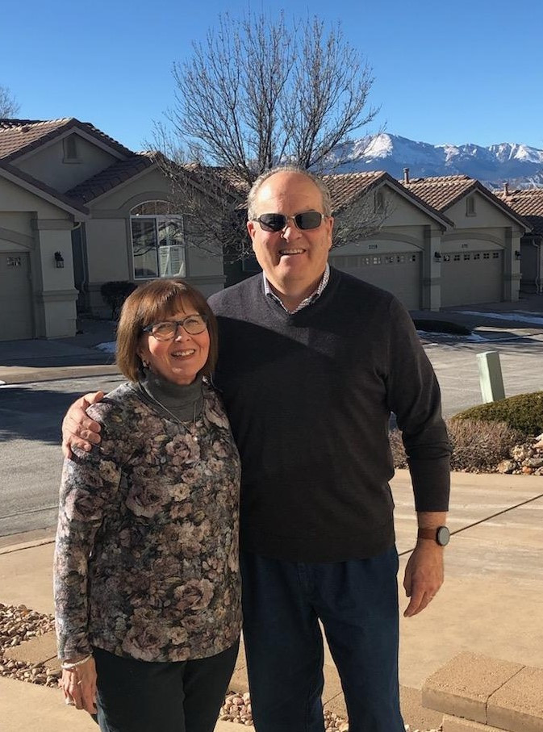
Longer version:
Bio for Victor Dawson
“Victor Dawson is Founder and President of Summit Group International, a global product sourcing and manufacturing company, primarily in Asia and Latin America.
He is a founding partner of Cuddle Clones, a company in Louisville, KY, that makes plush pets that look exactly like your pet.
Victor is also the Founder and CEO of As You Go, a ministry making it easy for people to share their faith – to spark a conversation that impacts eternity. He has also published a new book called As You Go and a song by the same name has been recorded.
He holds an undergraduate degree in Industrial Management from Georgia Tech in Atlanta and an Executive MBA from Washington University in St. Louis.

- He has been actively involved in CBMC (Christian Business Men’s Connection) for the past 27 years, first in St. Louis, then Houston, and now Denver, plus CBMC International, particularly China and South Africa. He has a strong belief and commitment to evangelism and discipleship and has been “doing the ministry” wherever he goes. He enjoys coaching and discipling men and sharing the Gospel “with gentleness and respect” with anyone who will listen.

- His lifetime vision and goal is to be an Ambassador for Christ and to go and make disciples of all nations by giving, loving and serving with integrity people around the world.

Victor is now part of the CBMC USA staff for National Ministry Development and is focused on Vision 650 to expand teams into 400 new cities by 2028. He was a member of the Board of Directors of CBMC USA for 7 years and CBMC International for 4 years, and a charitable organization in Denver, Kenzi’s Kids and Dolls for Daughters.
The best words to describe him are Ambassador for Christ, Entrepreneur, Global Business Owner, Speaker/Author, Business Coach, Servant Leader, and World Traveler.

Victor lives in Colorado Springs, Colorado with his wife of 47 years, Nan, and they have two adult children, a grandson (9), and a granddaughter (6).”

